***ANUDIP FOUNDATION***

A Project Report on

**ONLINE CAKE ORDERING SYSTEM**

By

Batch: ANP-C7344

Student ID: AF0368366

Name: Mrunal Mohan Patil

**Under the Guidance of**

Mrs. Rajshri Chandrabhan Thete

ONLINE CAKE ORDERING SYSTEM

The online cake ordering system allows user to check for various types of cake and purchase online. If the user likes a product he may add it to shopping cart. He may even pay through a credit card or cash delivery. Once the user makes a successful transaction, he gets copy of the shopping receipt on his email id. User has also option for ordering custom cakes according to their requirements like cake’s f flavor, size, shape and so on. Thus the online cake shopping project brings an entire cake shop online and makes it easy for both buyer and seller.

**Entities:**

* Customer
* Admin
* Cakes
* Payment
* Receipt
* Order
* Cake Shop

**VARIOUS ENTITIES:**

1. **Customer**

* Customer Id (Primary key)
* Name
* Contact No
* Email Address
* Residence
* Occasion

1. **Admin**

* Admin Id (Primary Key)
* Name
* Contact No
* Email address

1. **Cakes**

* Cakes Id (Primary key)
* Name
* Price
* Flavor
* Size
* Ingredient

1. **Payment**

* Payment Id (Primary Key)
* P Details
* P Method

**5.Receipt**

* Receipt ID (Primary Key)
* Amount

**6.Order**

* Order Id (Primary Key)
* Customer Id
* Cakes Id
* Cake Shop Id
* Quantity
* Description

**7.Cake Shop**

* Cake Shop Id (Primary Key)
* Name
* Contact No
* Email Address
* Location

**ENTITY RELATIONSHIP DIAGRAM – Online Cake Ordering System**

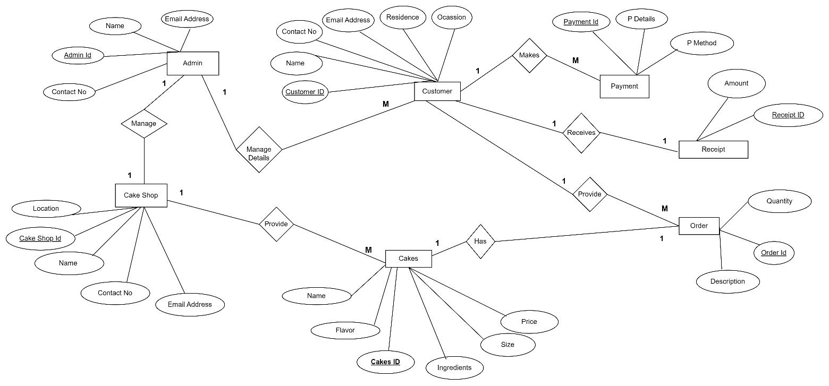

**CLASS DIAGRAM FOR Online Cake Ordering System:**

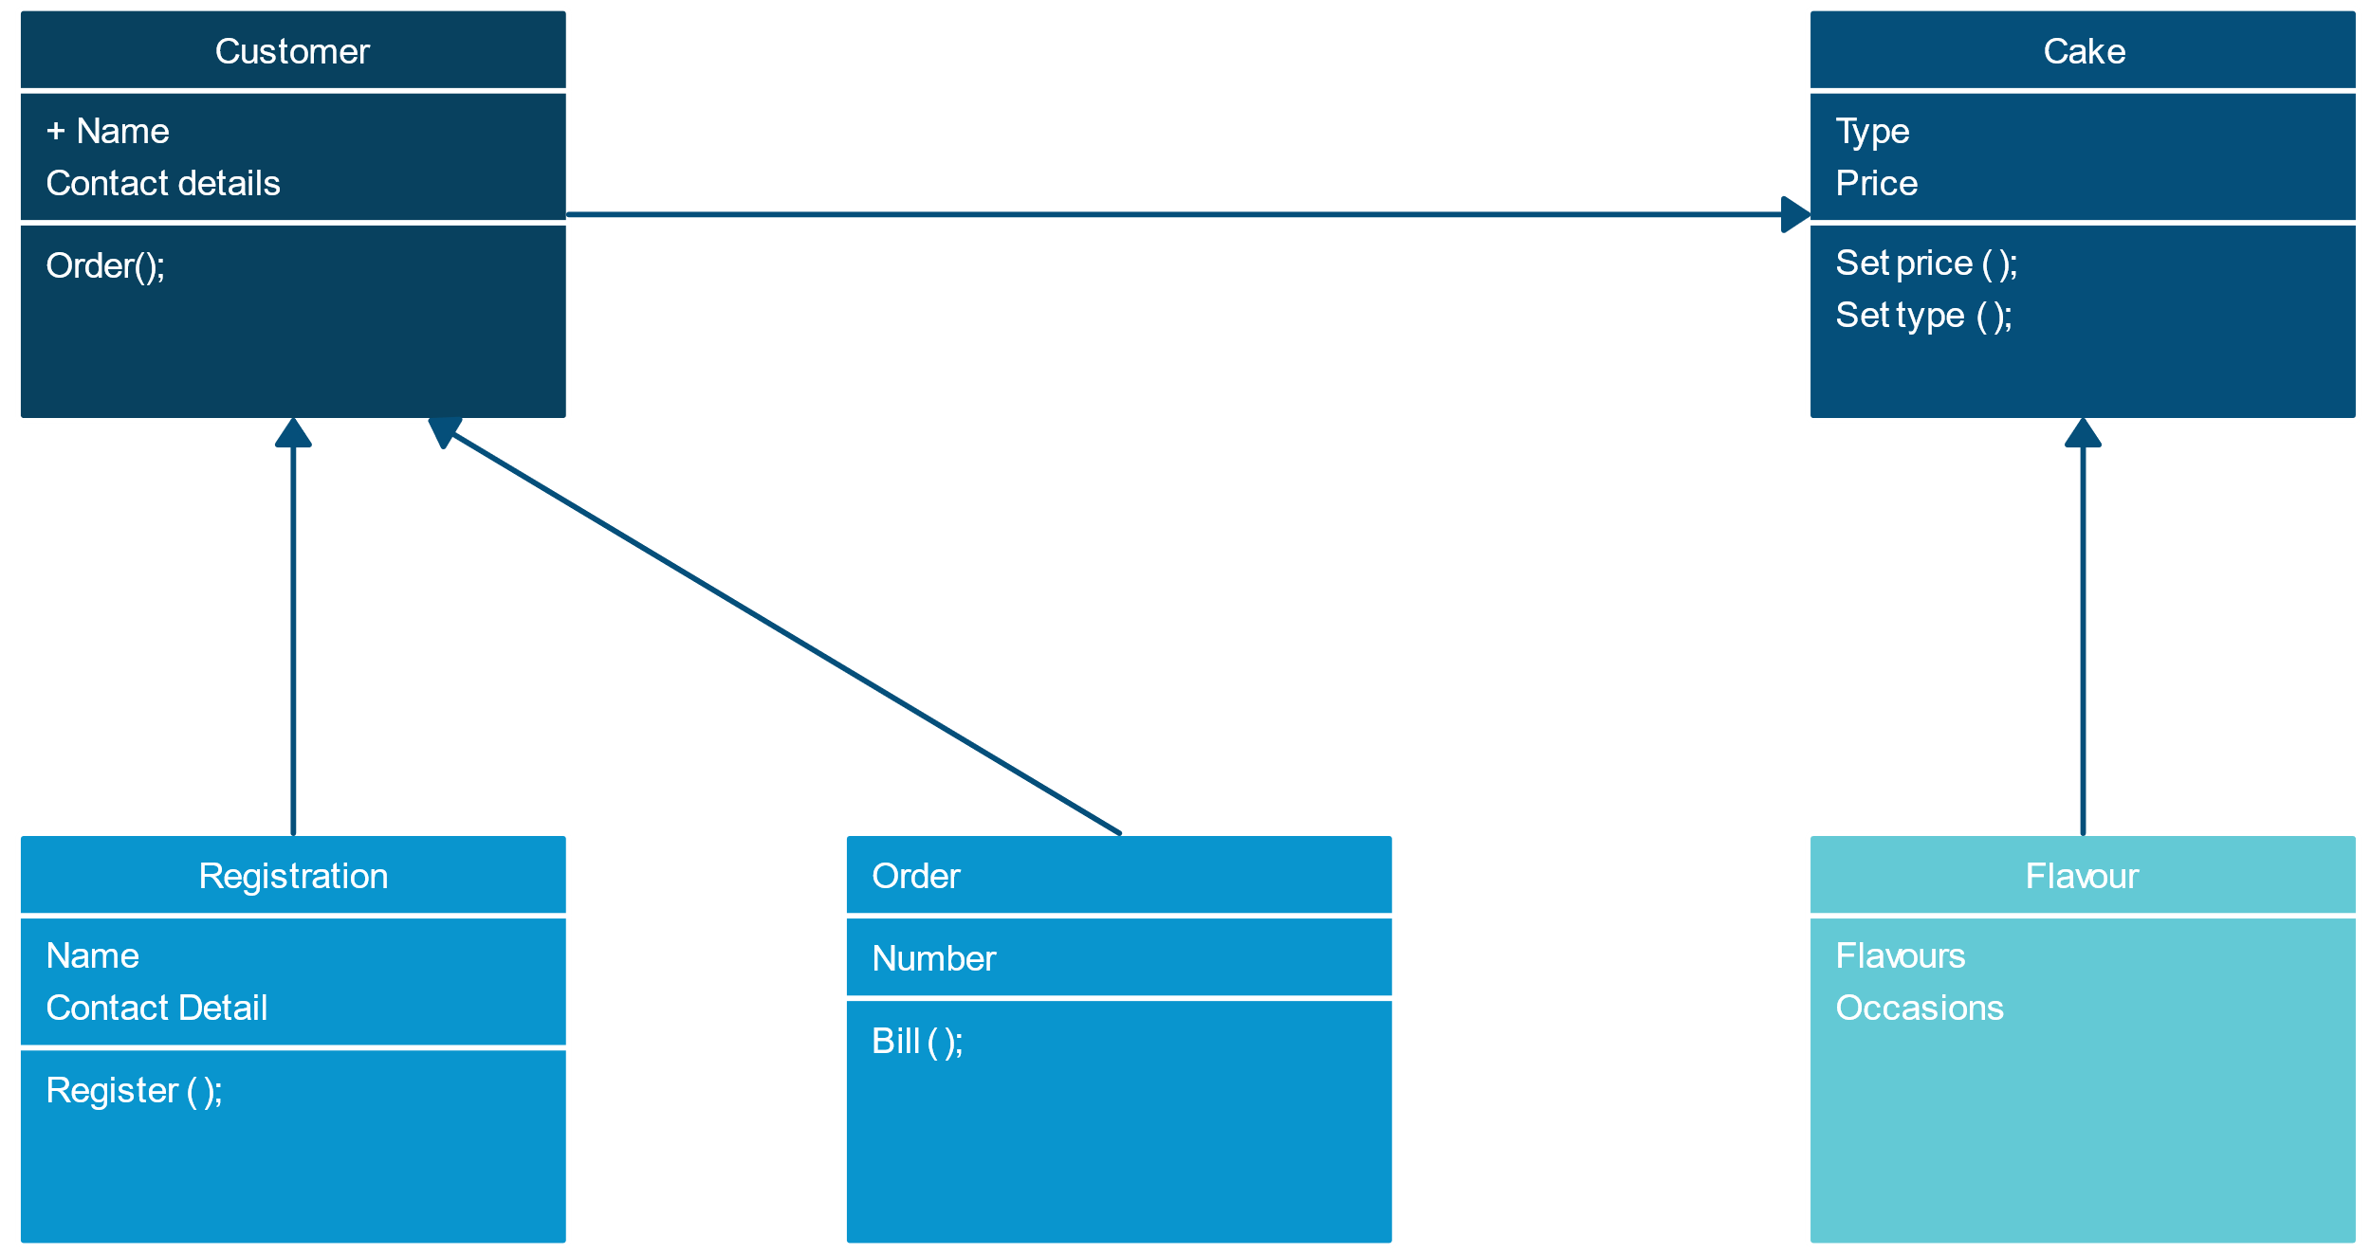

**CONCLUSION:**

In conclusion, Online Cake Ordering System helps to the Customer Order The Cake From The Remote Location along with different choices of Cakes and Flavour’s. Additionally they can make payment online and offline both.

**DATABASE CREATION QUERY:**

mysql> create database AnudipProject;

Query OK, 1 row affected (0.01 sec)

mysql> use AnudipProject;

Database changed

mysql> create table Customer(Customer_ID varchar(20) primary key not null,Name varchar(20) not null,Contact_No varchar(20) not null,Email_Address varchar(20) not null,Residence varchar(20) not null,Occasion varchar(20) not null);

Query OK, 0 rows affected (0.03 sec)

mysql> create table Admin(Admin_ID varchar(20) primary key not null,Name varchar(20) not null,Contact_No varchar(20) not null,Email varchar(20) not null);

Query OK, 0 rows affected (0.02 sec)

mysql> create table Cakes(Cakes_ID varchar(20) primary key not null,Name varchar(20) not null,Price varchar(20) not null,Flavor varchar(20) not null,Size varchar(20) not null,Ingredient varchar(20) not null);

Query OK, 0 rows affected (0.01 sec)

mysql> create table Payment(Payment_ID varchar(20) primary key not null,P_Details varchar(20) not null,P_Method varchar(20) not null);

Query OK, 0 rows affected (0.02 sec)

mysql> create table Receipt(Receipt_ID varchar(20) primary key not null,Amount varchar(20));

Query OK, 0 rows affected (0.01 sec)

mysql> create table Order(Order_Id varchar(20) primary key not null,foreign key (Customer_ID) references Customer (Customer_ID),^C

mysql> create table Cakes_Shop(Cakes_Shop_Id varchar(20) primary key not null,Name varchar(20) not null,Contact_No varchar(20),EmailAddress varchar(20)not null);

Query OK, 0 rows affected (0.02 sec)

mysql> create table Order(Order_Id varchar(20) primary key not null,foreign key (Customer_ID) references Customer (Customer_ID),foreign key (Cakes_ID) references Cakes(Cakes_ID),foreign key (Cakes_Shop_Id) references Cakes_Shop(Cakes_Shop_Id),Quantity varchar(20) not null,Description varchar(20) not null );